BÀI 4 – DATA-DRIVEN TESTING & EXECUTION (3/3 điểm)

1. Cấu trúc dự án:
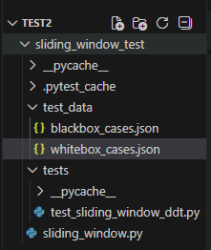
Blackbox_cases.json
[
{"id": "BB01", "description": "Valid normal", "arrays": [[10,20,30,40]], "n": 2, "expected_total": 3},
{"id": "BB02", "description": "Invalid - all arrays too short", "arrays": [[1],[2]], "n": 3, "expected_total": 0},
{"id": "BB03", "description": "Boundary len(arr)=n", "arrays": [[5,5,5]], "n": 3, "expected_total": 1},
{"id": "BB04", "description": "Boundary len(arr)=n+1", "arrays": [[1,2,3,4]], "n": 3, "expected_total": 2},
{"id": "BB05", "description": "n minimum = 1", "arrays": [[9,9]], "n": 1, "expected_total": 2},
{"id": "BB06", "description": "Empty input list", "arrays": [], "n": 10, "expected_total": 0},
{"id": "BB07", "description": "Large valid case", "arrays": [[1,2,3,4,5,6,7,8]], "n": 5, "expected_total": 4}
]

Whitebox_cases.json
[
{
"id": "WB01",
"description": "Normal case - multiple windows",
"arrays": [[1,2,3,4,5]],
"n": 3,
"expected_total": 3,
"expected_windows": {"(1, 2, 3)": 1, "(2, 3, 4)": 1, "(3, 4, 5)": 1}
},
{
"id": "WB02",
"description": "Array shorter than n → skip",
"arrays": [[1,2]],
"n": 3,
"expected_total": 0,
"expected_windows": {}
},
{
"id": "WB03",
"description": "Exact length = n → 1 window",
"arrays": [[7,7,7]],
"n": 3,
"expected_total": 1,
"expected_windows": {"(7, 7, 7)": 1}
},
{
"id": "WB04",
"description": "Empty arrays list",
"arrays": [],
"n": 5,
"expected_total": 0,
"expected_windows": {}
},
{
"id": "WB05",
"description": "Duplicate windows across arrays",
"arrays": [[1,1,1,1], [1,1,1,1]],
"n": 2,
"expected_total": 6,
"expected_windows": {"(1, 1)": 6}
},
{
"id": "WB06",
"description": "n = 1 (boundary min)",
"arrays": [[10,20,30]],
"n": 1,
"expected_total": 3,
"expected_windows": {"(10,)": 1, "(20,)": 1, "(30,)": 1}
},
{
"id": "WB07",
"description": "Multiple different windows",
"arrays": [[1,2,3,4,5,6]],
"n": 4,
"expected_total": 3,
"expected_windows": {"(1, 2, 3, 4)": 1, "(2, 3, 4, 5)": 1, "(3, 4, 5, 6)": 1}
}
]

Test_sliding_window_ddt.py

import json
import pytest
from pathlib import Path
from sliding_window import sliding_window_probabilities

DATA_DIR = Path(__file__).parent.parent / "test_data"

def load_cases(filename):
with open(DATA_DIR / filename, encoding="utf-8") as f:
return json.load(f)

whitebox_cases = load_cases("whitebox_cases.json")
blackbox_cases = load_cases("blackbox_cases.json")

@pytest.mark.parametrize("case", whitebox_cases, ids=[c["id"] for c in whitebox_cases])
def test_whitebox_cases(case):
probs, counter, total = sliding_window_probabilities(case["arrays"], case["n"])
assert total == case["expected_total"], f"{case['id']} - {case['description']}"

expected_counter = {eval(k): v for k, v in case["expected_windows"].items()}
for window, count in expected_counter.items():
assert counter[window] == count, f"{case['id']} window {window}"

@pytest.mark.parametrize("case", blackbox_cases, ids=[c["id"] for c in blackbox_cases])
def test_blackbox_cases(case):
_, _, total = sliding_window_probabilities(case["arrays"], case["n"])
assert total == case["expected_total"], f"{case['id']} - {case['description']}"

sliding_window.py

from collections import Counter

def sliding_window_probabilities(arrays, n):
window_counter = Counter()
total_windows = 0

for arr in arrays:
if len(arr) < n:
continue
for i in range(len(arr) - n + 1):
window = tuple(arr[i:i + n])
window_counter[window] += 1
total_windows += 1

probabilities = {
window: count / total_windows
for window, count in window_counter.items()
if total_windows > 0
}

return probabilities, window_counter, total_windows

2. Cách chạy:
python -m pytest tests/ -v --tb=short

3. Kết quả chạy: 14/14 test cases PASSED (xem ảnh đính kèm)
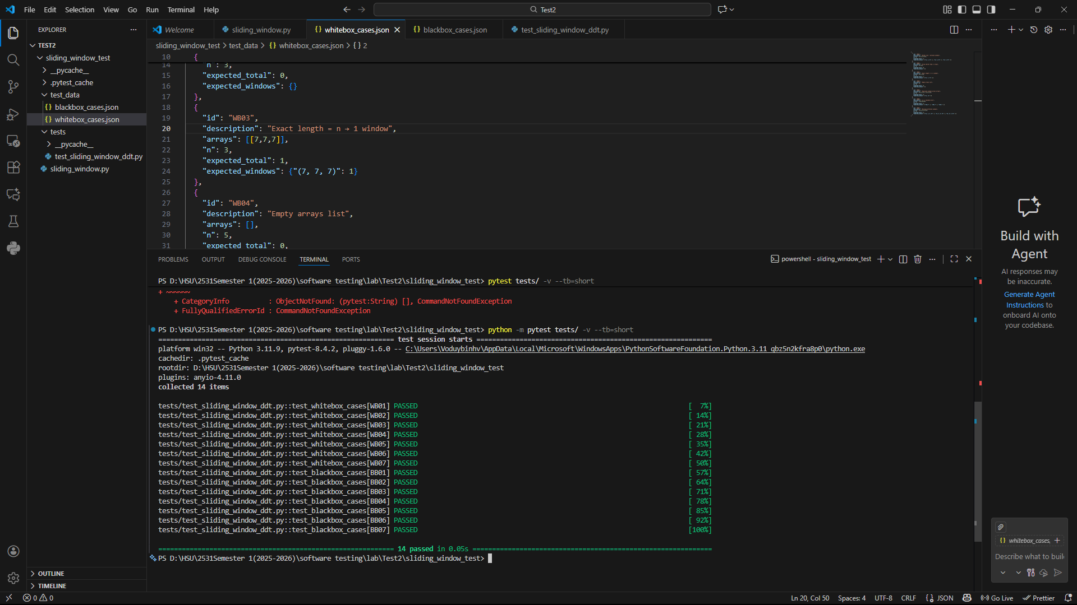
4. Bug Report:
"Hàm bị chia cho 0 và trả probabilities rỗng khi total_windows = 0"
Khi gọi hàm với arrays = [] hoặc tất cả mảng đều ngắn hơn n
Trong điều kiện total_windows = 0
Actual Result: probabilities = {} (rỗng) → ĐÚNG
Expected Result: nên trả về {} hoặc raise Exception rõ ràng hơn
Severity: Low (vì không crash)
Recommended Action: Thêm điều kiện if total_windows == 0: return {}, counter, 0

